**Name: Adrian P. Laurente**

**Section: BSIT-3**

**

**

**

**

****STEP6**

**STEP 7**

**Explain:** The console paused execution at the debugger line, allowing me to inspect code before running it.

**STEP 8**

I Remove the red dot in Sources panel and

Delete the debugger; line in JS file

**STEP 9**

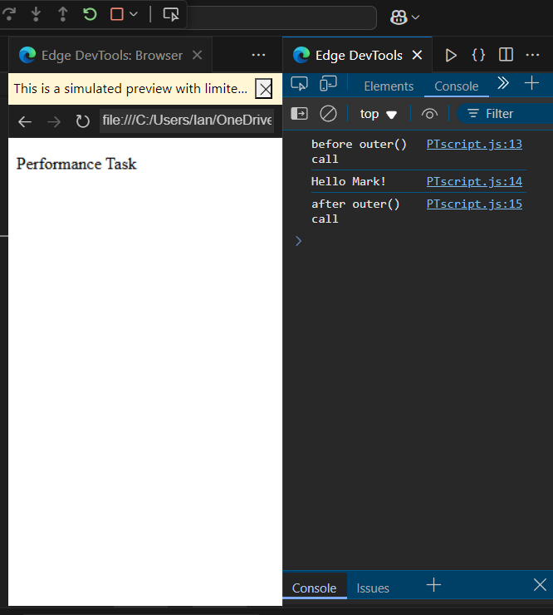

**Explain:** After resuming, the code continues and prints all three log statements in order.

**STEP 10 - 16**

I add breakpoints and refresh and set the 12th as new breakpoint then reload again then press the step over

**Step 17 Answer:** Step Over highlights the next line of code that will run without entering a function.  
  
**Step 18 Answer:** Each time Step Over is clicked, the console shows the next output line after it executes.

**Step 20 Answer:**

**done**  
1st click: into outer()  
2nd click: into inner()  
3rd click: return "Hello Mark!"